Q. Retrieve all columns from the employees table.

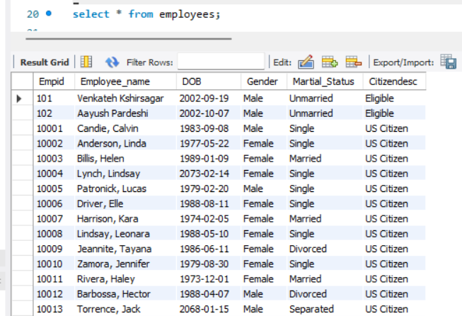

Q. Display only Employee_name and DOB of all employees.

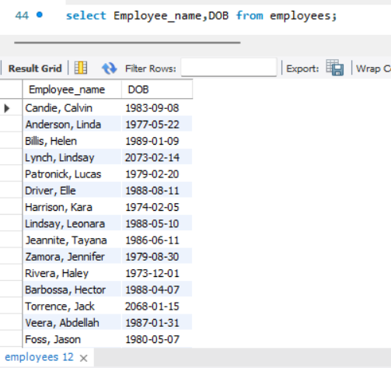

Q. Find all employees whose gender is Male.

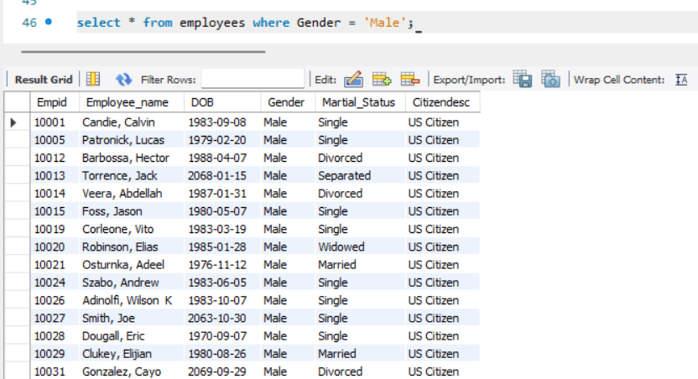

Q. List employees whose marital status is **Single**.

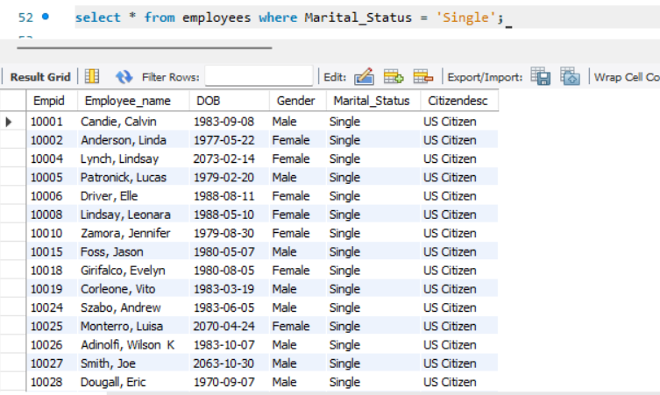

Q. Show employees born after **1 Jan 1985**.

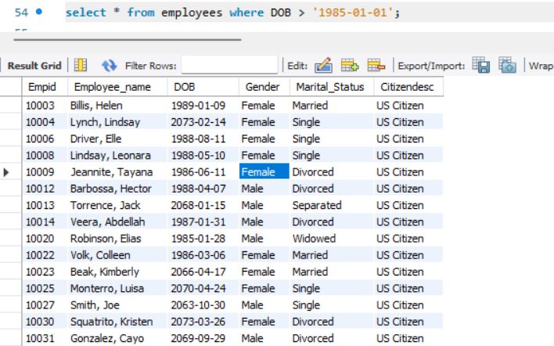

Q. Sort employees by Employee_name in ascending order.

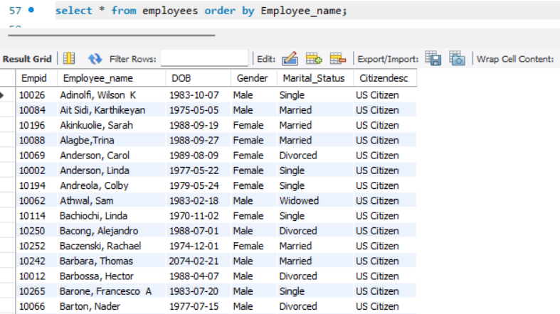

Q. Sort employees by DOB from oldest to youngest.

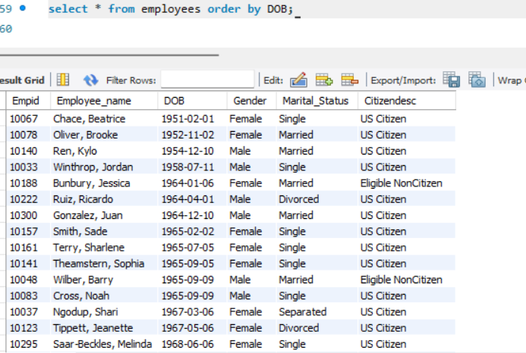

Q. Retrieve employees who are **Married** and are **Female**.

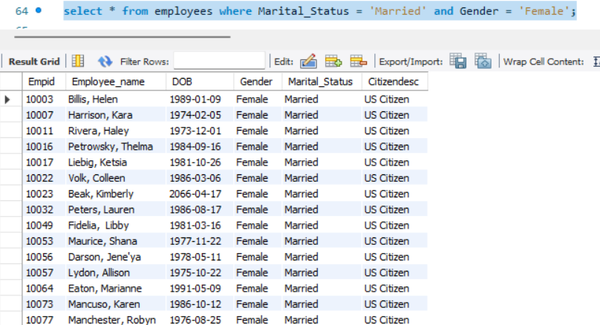

Q. Show employees who are **Single** OR born after 1990-01-01.

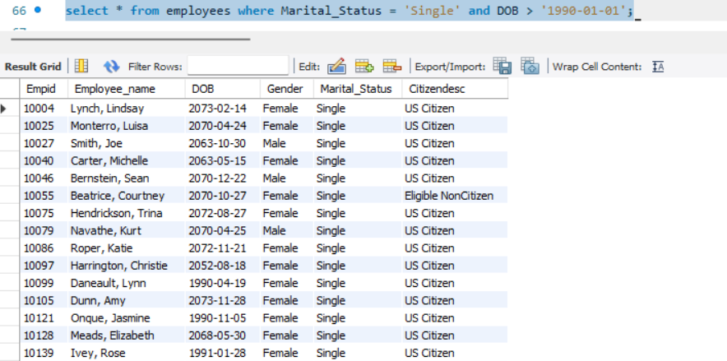

Q. Display employees whose DOB is between 1980-01-01 and 1990-12-31.

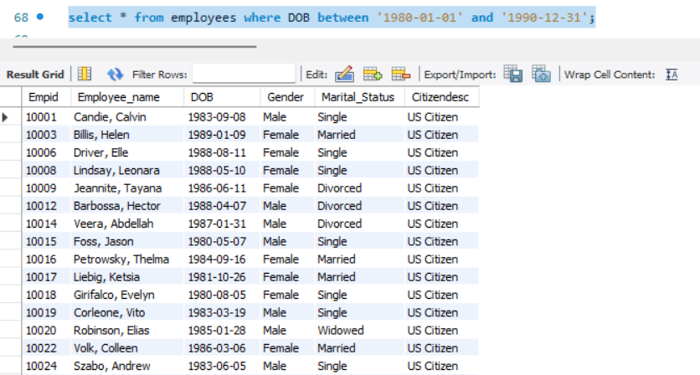

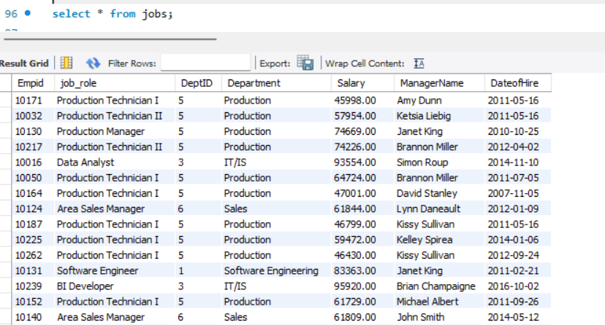

1. List all employees with their job roles and departments.

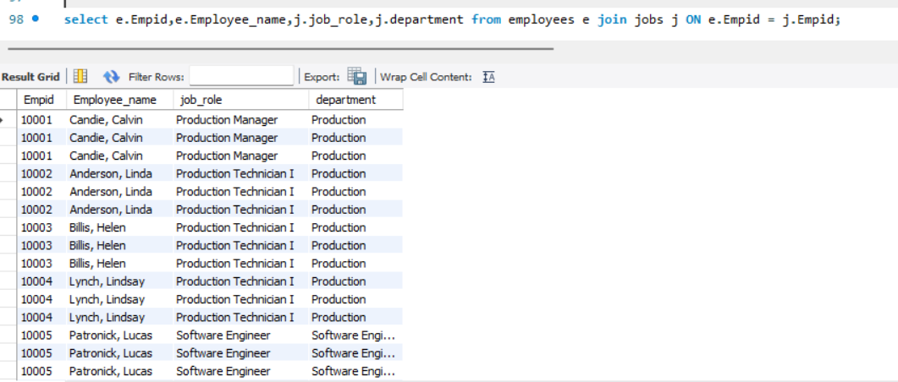

1. Find all employees hired after 2015-01-01.

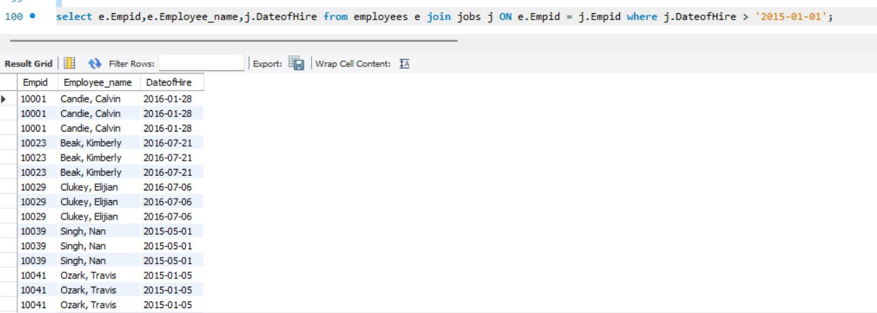

1. Get the total number of employees in each department.

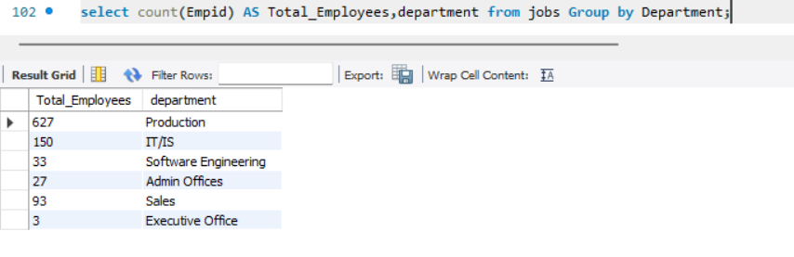

1. Show all female employees working in the ‘IT’ department.

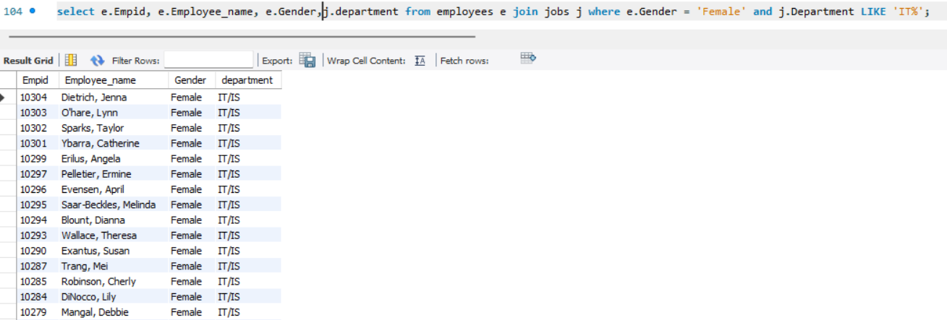

1. Find the average salary in each department.

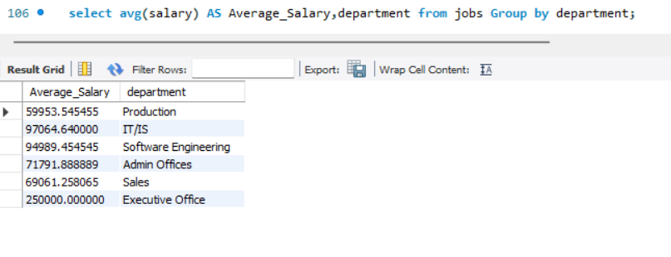

Q. Get the highest and lowest salary for each department.

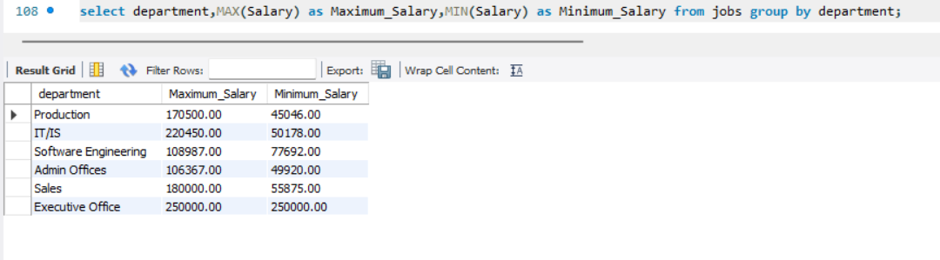

1. List employees with salary greater than 70000 along with their department names.

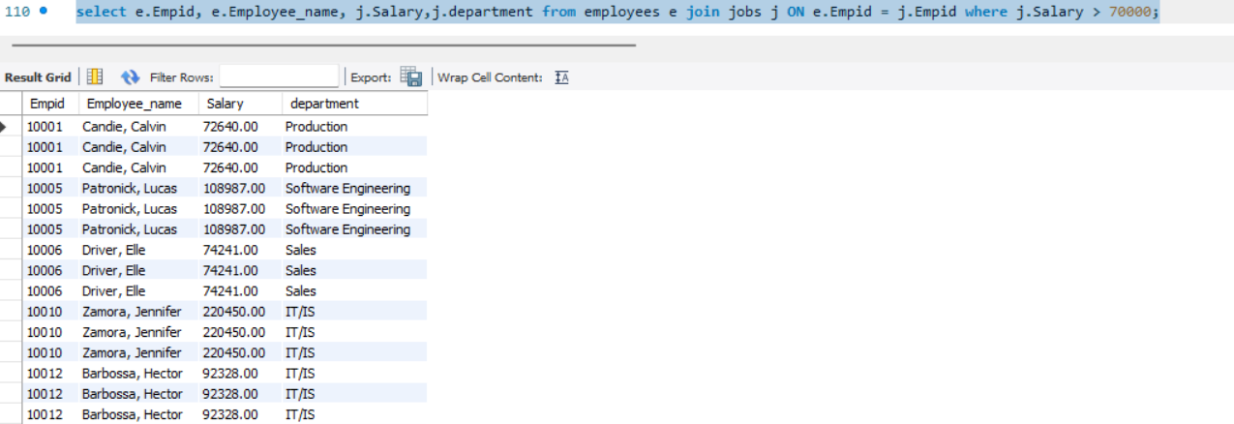

1. Find employees whose marital status is ‘Single’ and who earn more than 50000.

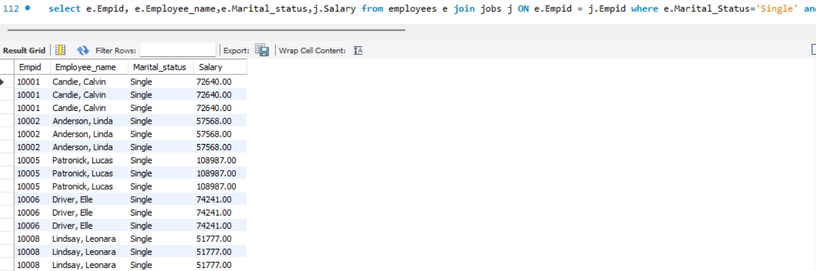

1. List the top 10 highest paid employees along with their job roles and departments.

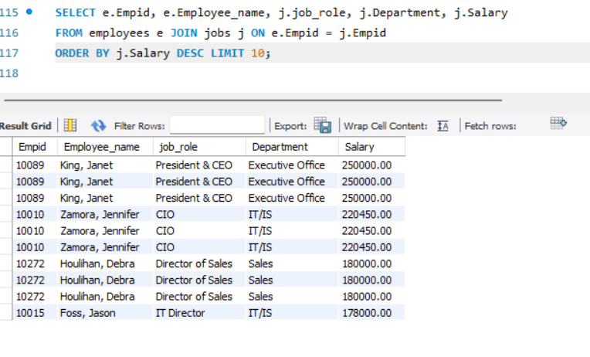

1. Find the department with the highest total salary expense.

